Evening Of …
February

Casino Sponsor $6,000
Tickets reserved for 10 guests, logo on invite, print ads and sponsor boards. MC acknowledgement at event, in newsletter, website and Facebook. Custom playing chips with company logo distributed to every guest, Casino Sponsor sign posted in casino lounge

Aces $2,000
Tickets reserved for 10 people, logo on invitation, print ads and sponsor boards. MC acknowledgement at event, newsletter, website, and Facebook

King $1,500
Tickets reserved for 8 guests, logo in print ads and sponsor boards. Acknowledgement in newsletter, website and Facebook

Queen $1,000
Tickets reserved for 6 guests. Company name in invitation, print ads, and sponsor boards. Acknowledgement in newsletter, website, and Facebook

Jack $750
Tickets for 4 guests with joint seating. Company name in invitation, print ads, program, and sponsor boards. Acknowledgement in newsletter, website, and Facebook
Red Apple Run for Diabetes
November

Presenting Sponsor $5,000
Name on front of t-shirts and flyers (if form received prior to May), top of printed materials, website, Facebook posts. Mention as presenting sponsor at event. Marketing display at event. Opportunity to have mascot/individual ride in lead car

Big Apple $2,000
16 runner/walkers in event. Logo set apart at top of t-shirt, printed materials, website, and multiple Facebook posts. Mention as presenting sponsor at event.. Marketing display at event

Apple Pie $1,000
8 runners/walkers in event. Logo on t-shirt, printed materials, website and Facebook page. 10’ x 10’ marketing display space at event

Apple Sauce $500
4 runners/walkers in event. Company or individual name on t-shirt, sponsor board, website and Facebook page

Apple Seed $250
Two runners/walkers in event. Company or individual’s name on t-shirt, sponsor board, website and Facebook page

Diabetes.. Dodge It! Tournament
August

Presenting Sponsor $5,000
Up to 6 teams; logo on Facebook, website, 2 sponsor boards. Name on front of t-shirts and flyers (if form received prior to May), 8 spectators; optional entry display space and recognition by MC

Extreme Dodgeballer $2,000
Up to 6 teams; logo on Facebook, website, 2 sponsor boards, logo on t-shirts, 8 spectators, option for display at venue; optional banner display at entry and recognition by MC

Court Sponsors $1,000
Up to 4 teams; logo on Facebook, website,
sponsor board, t-shirts; 8 spectators; a Court for optional decorating/banner display

Gold Ball Sponsor $500
2 teams; logo on Facebook, website, sponsor board, t-shirts; 6 spectators

Bronze Ball Sponsor $250
1 team; logo on Facebook, website, sponsor board, t-shirts; 4 spectators

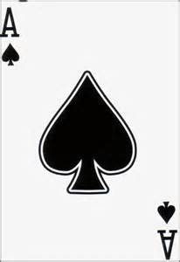
Evening of …

Casino Sponsor $6,000
Ace $2,000
King $1,500
Queen $1,000
Jack $750
Circle one sponsorship level from each column and enter TOTAL: $___________________
Contact Name: ___________________________ Website : __________________________________
Company or Name as you would like it listed: ___________________________________________________
Email: ___________________________________ Phone: ____________________________________
Payment preference (circle one) : In Full OR __ installments of $______

Please make checks payable to Better Health. Credit card payments may be made online, by phone or in person.
1422 Bragg Boulevard, Fayetteville, NC 28301 • 910-483-7534 • www.betterhealthcc.org

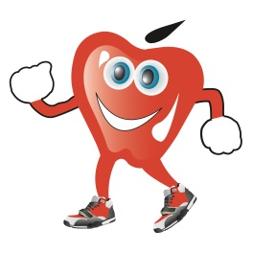
Red Apple Run for Diabetes

Presenting Sponsor $5,000
Big Apple $2,000
Apple Pie $1,000
Apple Sauce $500
Apple Seed $250

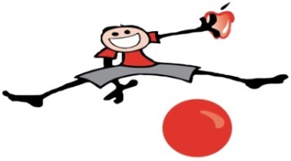

Diabetes.. Dodge It!

Presenting Sponsor $5,000
Extreme Dodgeballer $2,000
Court Sponsor $1,000
Gold Ball $500
Bronze Ball $250

In addition to the recognition on the reverse side, Corporate Sponsors receive:
* Thank You recognition on the Better Health sign at 1422 Bragg Blvd for 1 month (avg. 900,000 travelers per month per NCDOT)
* Premier Facebook and Website recognition as a Corporate Sponsor
*MC recognition at each event as a Corporate Sponsor
* Premier Newsletter recognition as a Corporate Sponsor
* A thank you plaque or print for display
* Check presentation photo opportunity with Board President and Executive Director
The total sponsorship amount can be paid in full or in installments throughout the year. Total due by June 30th of the fiscal year, after all events have concluded.

