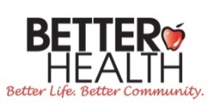 Better Health Holiday Honor Card Contest Entry
Better Health is a non-profit in Fayetteville, NC that helps address unmet healthcare needs through education, referral and assistance. Programs include diabetes management, emergency direct aid, childhood obesity prevention and medical equipment loans.
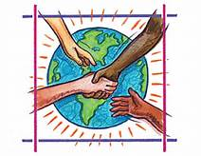
Artwork Theme: Helping People In Need
Entrant's Name * (Entrant should be 15 years of age or younger)
First __________________________ Last __________________________
Age * __________________________ Phone Number __________________________
Birthday * __________________________
Street Address ________________________ City __________________________
State __________________________ Zip Code __________________________
Tell us about yourself and your picture! ___________________________________________________________
____________________________________________________________________________________________
Parent or Guardian's Name *____________________________________________________
Parent or Guardian's Email *____________________________________________________
Parent or Guardian's Permission * ____________________________________________________
I give permission for my child to enter this contest and certify that the above information is correct. I understand that in doing so, my child’s artwork, name, age, etc. may be printed on annual Holiday Cards and/or posted on social media and Better Health’s website.
Make sure that your artwork is on a 8" x 11" piece of paper and mail this form and art to:
1422 Bragg Blvd, Fayetteville, NC 28301 or email to director@betterhealthcc.org
Visit www.betterhealthcc.org to learn more about Better Health!
Entries must be received by November 1, 2016

