Better Health’s
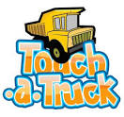
Saturday, May 2nd, 2020
Dirtbag Ales
5435 Corporation Dr, Hope Mills, NC 28348
9-10 Sensory Friendly, 10-2 all the horns and lights!

SPONSORSHIP LEVELS

The Big Rig ($2,500)
Up to 10 attendees; sole sponsor logo on rack cards and flyers (if received by February 1, 2020), priority placement on Facebook, website, sponsor board, name on promotional giveaways (possible wrist bands, etc), 10 x 10 vendor space and recognition on radio interviews and press release

Excavator ($750):
Up to 8 attendees; logo on Facebook, website, sponsor board, 10 x 10 vendor space

Tow Truck ($250):
Up to 4 attendees; logo on website, 10 x 10 vendor space

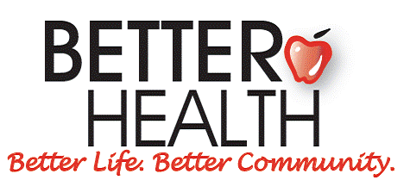

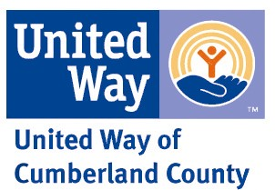

Name as it should appear:_____________________________________ (email logo to director@betterhealthcc.org)
Would you like to have a vendor space at the event? (please bring table/chairs) Yes No
Phone Number: _____________________________________ Email: ____________________________________________________

Event is rain or shine!
Deadline for print marketing materials is April 15th, 2020 unless otherwise noted
Please make checks payable to: Better Health, 1422 Bragg Blvd. Fayetteville, NC 28301
Contact director@betterhealthcc.org 910-483-7534 to make payment installment arrangements if necessary

Form may be submitted to director@betterhealthcc.org

