Frequently asked questions

Fayetteville Fit

Date of publication
Is my child eligible?

A family-based approach to health and wellness
If your child is between 2 and 18 years of age, with a Body Mass Index (BMI) above the 95th percentile, your family is eligible. Go to www.cdc.gov or ask your health care provider to find out your child’s BMI.
Do I need a referral?
Yes. You must have a referral from your child’s health care provider to join Fayetteville Fit.
What is the cost?
While there is no cost to participating in Fayetteville Fit, the best treatment approach includes both Fayetteville Fit and clinical care. Fayetteville Fit requires patients to attend at least 3 appointments with your health care provider during your time in the program. You are responsible for co-payments for those medical visits according to your insurance plan.
1612 Camden Road
Fayetteville, NC 28306
910-483-7534
910-483-2157
www.betterhealthcc.org

Active recreation through community-healthcare engagments (ARCHES)
A project sponsored by The Duke Endowment

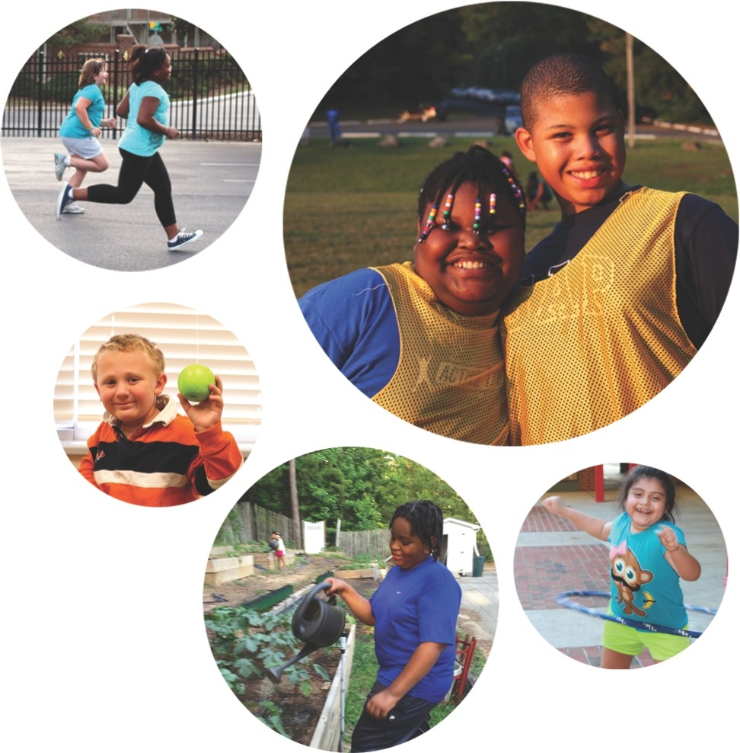

A healthy future begins here
Fayetteville Fit uses the evidence-based community-healthcare partnership model that was developed in 2009 at Duke Children’s Hospital and Durham Parks & Recreation in Durham, North Carolina, where over 8,000 families enjoy significant lifestyle changes, such as:
- A more active life
- Family meals that are delicious and nutritious
- Fewer food battles
- Confident and secure children
- Good approaches to teasing and bullying
- Improved health for everyone!

”I think any kid should come because it’s so much fun! It doesn’t matter if you can run fast or if you are young or old. everyone works together and has fun together.” – Jana, 6 (participant, DUrham NC)
What is program?
- A free wellness program for YOUR FAMILY!
- Trained, passionate, and supportive staff
- Sports & games, cooking classes, gardening, and more!

how do i join?
Ask your health care provider to sign you up. You can also register at: www.betterhealthcc.org

Location: Massey Hill Rec Center
1612 Camden Road
Fayetteville, NC 28306
Times: Tues and Fri 6-8 pm
Website: www.betterhealhcc.org

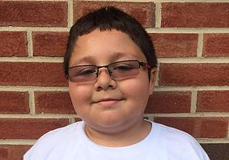

“everyone is really nice to me and the staff keeps cheering me on so i can do it and it makes me want to come every day.” – karol, 11 (participant, durham nc)

prepare to have fun!
- Each child must have an adult workout partner!
- Please dress your child (and yourself!) in loose-fitting clothing and comfortable sneakers
- Play hard, Play fair, Play safe, Play as a team

what to expect at the clinic?
- Routine clinic visits
- Child should be fasting
- Arrive 15 minutes prior to appointment time
- Bring all medications
Contact program connector Krystal with general program questions: 910-483-7534
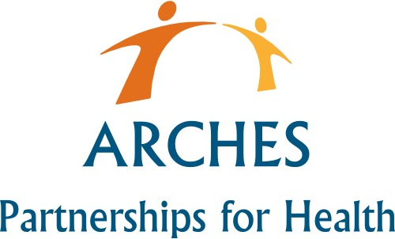

Company Name
Street Address
Address 2
City, ST ZIP Code
Phone (555)555-0125
Fax (555)555-0145
Web site address

