Sept 2019
SESSIONS ARE TUESDAYS AND FRIDAYS 6-8 PM AT 1612 CAMDEN RD
Sunday | Monday | Tuesday | Wednesday | Thursday | Friday | Saturday
1 | 2 | 3 | 4 | 5:30 PM 5 | 6 | 7
 |  | Cooking with Anna Activities w/ Lisa |  | ORIENTATION AT  1422 BRAGG BVD | Dodgeball  $ Double Fit Bucks $
8 | 9 | Black Girls Run 10 | 11 | 12 | 13  Yoga with Mittals  Activities w/ Lisa | 14
*LOCATION WILL CHANGE- KIWANIS REC*
Games w/ Amanda
15 | 16 | 17 | 18 | 19 | 20 | 21
Yoga with Mittals
Sports & Activities
Fit Buck Exchange!
22 | 23 | Black Girls Run 24 | 25 | 26 | 27 | 28
Bring Water!!!! |  | *LOCATION WILL CHANGE- KIWANIS REC* |  |  | Relay Races and  Team Building
29 | 30 |  |  | Be sure you have the Remind app! We use this to share location changes, reminders, and cancellations! |  | 6-6:10 LAPS  6:10-6:30 FREE PLAY  6:30-6:45 WARM UPS  6:45-8 CHOICES
Black Girls Run 13
Questions?  cher@betterhealthcc.org  910-483-7534 |  |  | 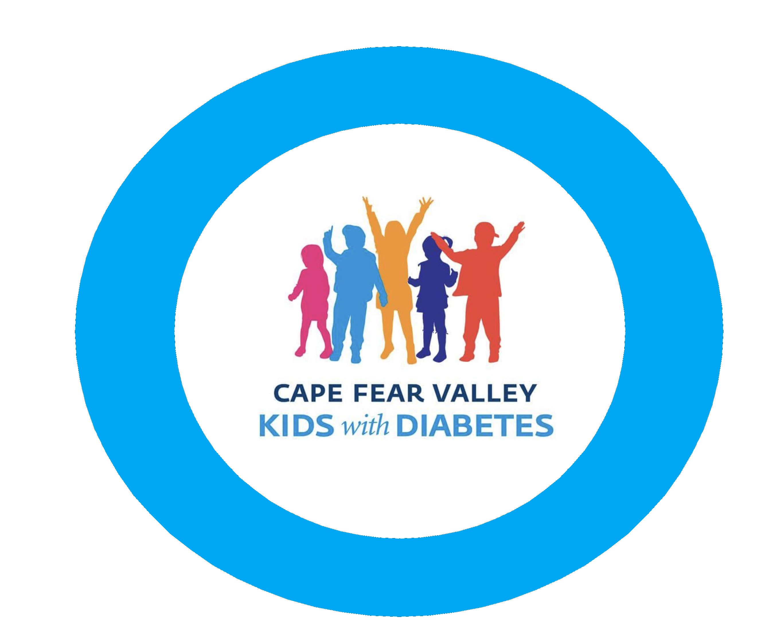
Cross Creek Pediatrics Fayetteville Children’s Clinic

