fayetteville fit  A free wellness program  New Participant orientation  When  First Weds of each month, 10 am  Where  Better Health office  1422 Bragg Boulevard  Fayetteville, NC 28301  Fayetteville Fit is a family program! Adult guardians must attend each session and participate with child or teenager.  Learn more @ www.betterhealthcc.org  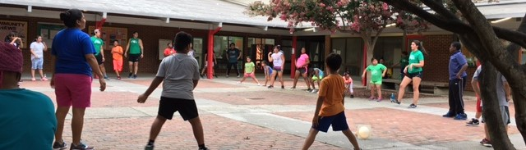 | exclusively  For patients and families of CFV Endocrine Center and other partnering pediatric offices  hours  Tues & Fri  6pm – 8pm  join us for  Basketball  Soccer  Dance  Cooking  Frisbee  & More!  Earn Bucks  Redeem for gift cards, sports equipment, FF gear, and more!

Ready to join the fun at Fayetteville Fit?  How to get started  - Register for and attend an orientation session (dates on the front of this flyer) 910-483-7534  - Parents must stay and participate in the orientation and all other FF activities  - The entire family should come dressed in workout clothes for the orientation  Rules and Expectations  Please read ALL rules before attending Fayetteville Fit  - A parent/guardian (age 18+) MUST be present with the participant at every session and remain as active as possible  - Both the participant and guardian must wear appropriate workout clothes: close-toed shoes, active wear, minimal jewelry.  - If siblings of a participant are attending, a parent/guardian MUST complete waiver form before participating. Parent/guardian MUST stay with child at all times and assume full responsibility for their safety.  - Participants are only allowed to use rooms reserved for Fayetteville Fit and only when a staff member/volunteer is present  - Strive to attend Fayetteville Fit at least one day per week! Work hard, have fun, and remember your Healthy Lifestyles goals! | FAYETTEVILLE FIT  MASSEY HILL REC CENTER  1612 CAMDEN ROAD  FAYETTEVILLE, NC  contact us  910-483-7534  fayfit@betterhealthcc.org  follow us  Facebook:  Fayetteville Fit  Instagram:  Fayetteville Fit  Questions?  Contact our Program Connector, Krystal Jimenez at  fayfit@betterhealthcc.org or 910-483-7534

